Harvest Craftwork 2020

BEFORE THE SERVICE
Have a go at making a harvest person from a piece of fruit or vegetable that you have. For example, you could get a carrot and put eyes, nose, mouth, arms and legs on it and even some clothes! Bring it along to show us on Sunday morning.

We are starting a time of craftwork from 10.00-10.30 a.m. on Sunday morning immediately before the service
- We need pictures of fruit and veg to colour and cut out on Sunday. You may like to use these or draw your own.
- You will need to have them printed out ready to use on Sunday. You can colour and cut them out beforehand or with us in the morning.

YOU WILL ALSO NEED
- a paper plate or get a piece of card, draw round it, and then cut it out
- scissors
- glue or Sellotape
- crayons, felt pens etc
- a plastic container with a cap or lid & dry rice / pasta / lentils to make some harvest maracas
IF YOU WOULD LIKE TO JOIN US BUT DO NOT HAVE THE LOG IN DETAILS EMAIL CATHARINE AT cgrievson@btopenworld.com and come and join in the fun.

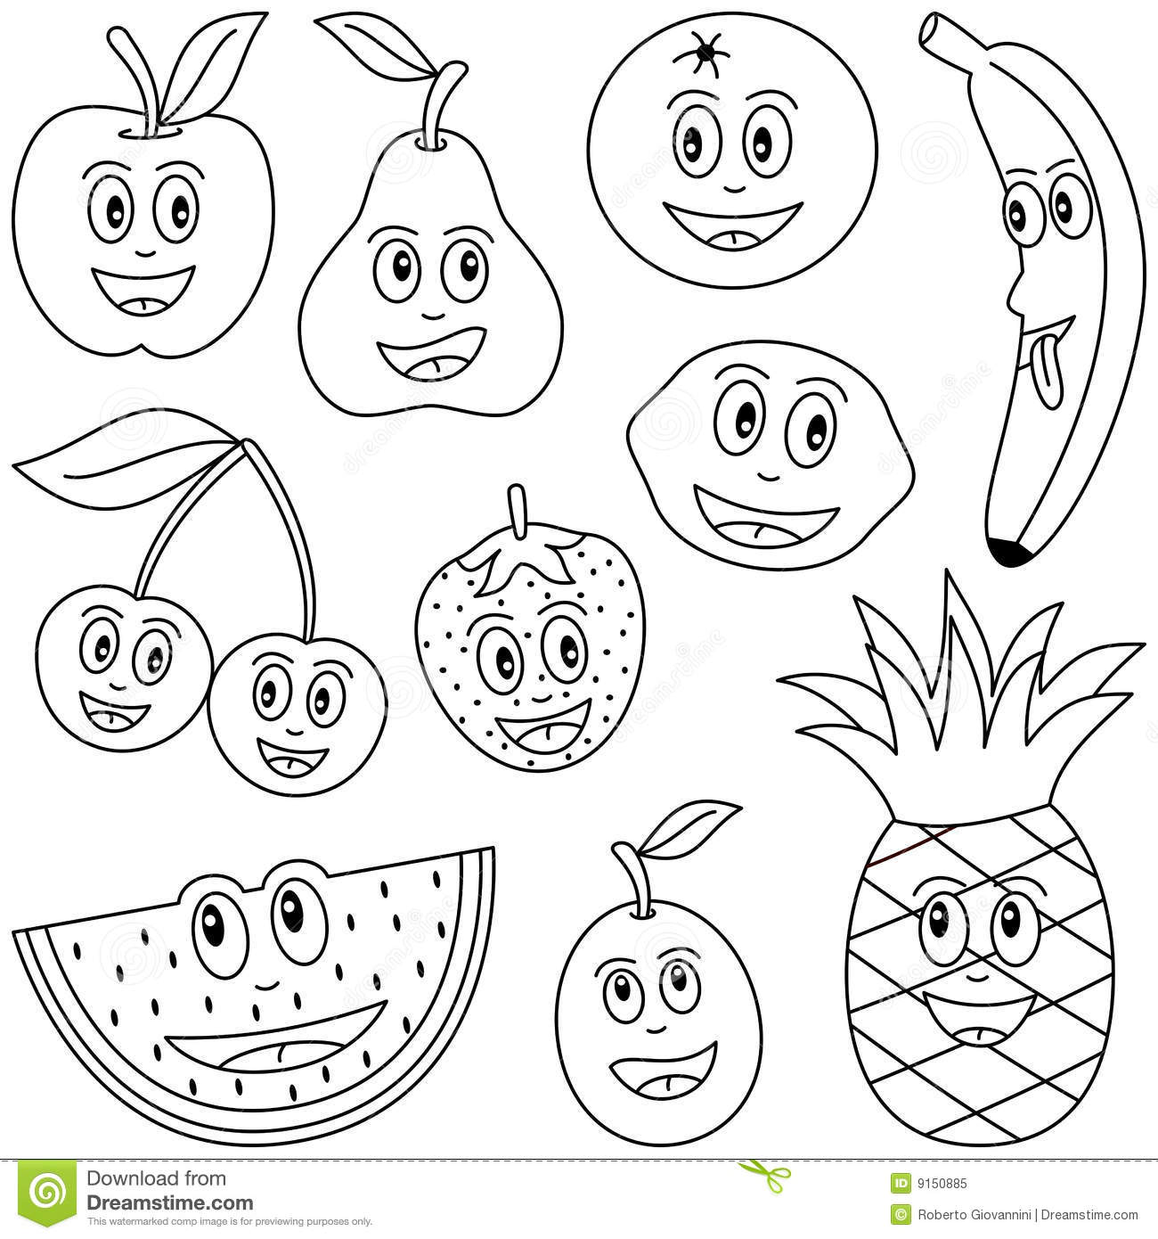
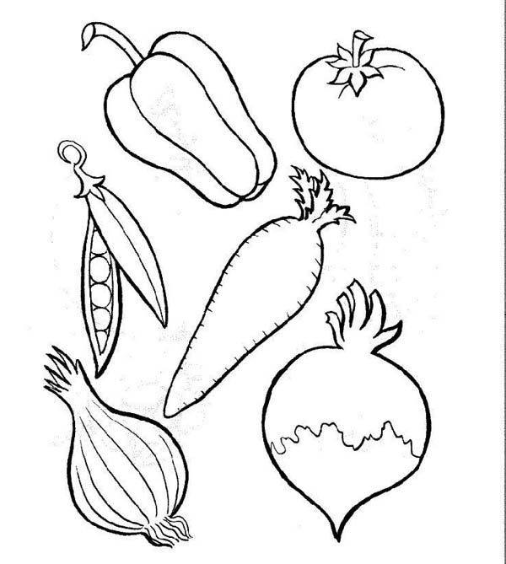

You may like to draw eyes on the vegetables as well.

